# CHAPTER ONE

# INTRODUCTION

## BACKGROUND OF THE STUDY

E-Learning has its historical background in about 30 years of development in computer based on the training and education. With the growth of the internet this kind of training became much more accepted and the creation of multimedia contents and systems to manage learning activities went on faster. Additional e-learning is based on a long tradition of teaching and learning experience. The larger worlds Information Technology and Education and Training influenced the new term e-learning and so e-learning became a subset of both of them.

Nowadays, e-learning refers to learning that is delivered or enabled via electronic technology. It encompasses learning delivered via a range of technologies such as the internet, television, videotape, and computer-based training. In principle, e-learning is a kind of distance learning. Learning materials can be accessed from the web or intranet via a computer and tutors and learners can communicate with each other using e-mail, chat or discussion forums.

Over the last decade, researchers and practitioners have developed a wide range of knowledge related to electronic learning or e-learning. This movement has affected different elements and components; infrastructures, tools, content-oriented applications, human-computer interactions, pedagogical issues, methodologies and models, case studies and projects. This chapter briefly describes the overall idea of the development of e-learning system for OGITECH by using Apache, PHP and MySQL. This chapter includes objectives of the project, scope of work, problem statement and features of project before developed the own sites.

Therefore, it can be used as the main method of delivery of training or as a combined approach with classroom-based training. It can be valuable when used as a part of well-planned and properly supported education and training environment, but e-learning is not a magic bullet that replaces existing pedagogical theories and approaches.

Nevertheless, it has almost everything that those theories need to get implemented.

Many learning and technology professionals believe that e-learning will have become state of the art when we will stop referring to it by a separate name and begin considering it as an integral part of a complete learning environment.

## 1.2 OVERVIEW OF THE EXISTING SYSTEM

Currently in Ogun State Institute of Technology, lecturing of student is done manually. The major problem of the current system is that lecturers need to be present in the school to lecture students. Most lecturers in this institution do teach in other institution and sometimes they might not be present to teach the students. As a result of this, lecturers are unable to complete the course content of a particular course thereby leading to failure of student in examination.

## 1.3 PROBLEM WITH THE EXISTING SYSTEM

The above stated case study encounters the following listed problems.

1. Insufficient lecturing time due to events and appointment in other schools
2. Insufficient lecturing facilities e.g. lecture rooms
3. Large record of student failure
4. Improper assignment submission record

## 1.4 THE OVERVIEW OF THE PROPOSED SYSTEM

The propose system is going to be automated web-based application where lecturers can upload lectures in form of video, audio and text. This project will also provide an avenue for posting of assignment, practical, and quiz as well as submission.

## 1.5 OBJECTIVES OF THE STUDY

Both e-learning system and workflow system tend to solve the same very general problem of having or many actors executing an activity or graph for activities and producing something. Therefore, the main components of such a system in both cases are actor, activity, and product. The goal of an e-learning system is the “learning”. The main actor, the learner (students) is expected to learn, to acquire new knowledge and competencies, through the execution different structured learning activities.

1. To provide interface between lecturer and student, where student don’t needs to go to every lecturer room just to make a simple discussion. In fact, this project comes out to upgrade and develop learning process among the students.

2. To provide a medium where students can be able to download note and tutorial in the easy way.

3. To provide a medium where lecturers can be able to upload tutorial.

4. To provide a system that will support class activities by giving students opportunities for further exploration, discussion, and exchange of ideas outside class. For this purpose, it is necessary to go beyond learning simple reusability of material in repositories of learning objects and find solutions in order to build significant learning scenarios or programs that enable students to achieve real competency gains while reinvesting learning objects.

**1.6 SCOPE OF STUDY**

The scope of work in this project is stated as given:

1. To develop the system by using Apache, PHP and MySQL.

2. To serves an administrative function by giving student’s access to course documents and other course materials for each courses they were taken.

3. To send latest announcement and news that is related for each course.

4. To display course related information on the link and reference item.

5. Provide FAQ (frequently ask question) and add a comments in this system where students and lecturer be able to ask questions and submit their comments.

6. Provide a simple of IQ Test to students.

## 1.7 LIMITATION OF THE STUDY

I will totally not conclude that this project will effectively handle all the problems encountered due to the change in technology from time to time, but with accuracy, this project will be able to handle all necessary problems encountered by the above case study except that this software will not be able to do the result computation of students and submit assignment for individual student.

## 1.8 DEFINATION OF TERMS

1. **PHP:** is a server-side scripting language designed for web development but also used as a general-purpose programming language. As of January 2013, **PHP** was installed on more than 240 million websites (39% of those sampled) and 2.1 million web servers.
2. **MySqlApache:** is a freely available Web server that is distributed under an "open source" license. Version 2.0 runs on most UNIX-based operating systems (such as Linux, Solaris, Digital UNIX, and AIX), on other UNIX/POSIX-derived systems (such as Rhapsody, BeOS, and BS2000/OSD), on AmigaOS, and on Windows 2000.

# CHAPTER TWO

# 2.0 LITERATURE REVIEW

## 2.1 INTRODUCTION

This literature review focuses on the barriers, and critical factors, to the uptake of online training or ‘e-learning’ in the aged care industry, and the critical factors that will support its dissemination.

Barriers to e-learning are explored here under two principal headings: the barriers that inhibit the uptake of e-learning by employees, and the barriers that inhibit employers from offering e-learning to their workforce. We find that ‘blended’ models of e-learning are universally deemed to be the most successful, combining the convenience of online platforms with the advantages that come from learning in groups with ready, interactive access to mentors, tutors, and other learning support services, on either a face-to-face basis or through videoconferencing or Web3 interactive technologies. Comprehensive induction and orientation to technology, and ongoing technological guidance are fundamental to successful e-learning for older adult learners. The interaction that occurs between adult learners is a critical factor in maintaining the engagement of participants.

E-learning is a largely under-utilized training and educational tool in the aged care industry despite the obvious advantages it can bring. In recognition of this Aged and Community Services Australia (ACSA) determined to explore and support the use of e-learning by aged care organizations. ACSA was successful in attracting funding from the Department of Employment, Education and Workplace Relations to develop an aged care industry plan to:

1. Embed e-learning, and its principles, into workforce development plans; and
2. Identify strategies to assist the sector to realize the full potential of e-learning.

The review focuses on the barriers that may militate against the successful participation in e- learning of populations who make up the bulk of the aged care workforce: mature or older workers, women, people (predominantly women) of non-English speaking backgrounds, and Indigenous persons. The aged care industry is also keen to attract school leavers and tertiary graduates, hence barriers that might affect the participation of younger people in e-learning are also considered.

Despite the prevalent myth that older female workers are not keen participants in e-learning, many are well aware of the need to upgrade their skills and qualifications and are eager to participate when their particular needs are addressed, including their need for appropriate technological orientation, for literacy and/or English language support, for courses that acknowledge their existing ‘shop floor’ competency and professional expertise, and for courses that take account of their non- work time and energy commitments. Self-efficacy and self-confidence are more critical factors associated with successful e-learning than factors such as age, gender, previous computer experience, home computer ownership, job position, education levels, ethnicity or English language competency, though each of these factors may have to be actively addressed. Best practice e- learning programs have established that while each of these factors may provide an initial barrier, they can be neutralized or turned to advantage when directly addressed through careful planning of the introductory stages of programs and program design. Older workers want e-learning that stretches but does not stress them, and they prefer e-learning that brings them into contact with other learners, creating communities of practice. Employers who recognize e-learning as a shared investment by workers and management, who provide their staff with computer access and allocated e-learning time, and who actively champion e-learning in their workplace, are likely to reap the very substantial benefits of e-learning.

## 2.2 Strategic Importance of e-Learning

The present and projected needs of business organizations amidst today’s global trends, communicate the viability and strategic value of e-learning. This section addresses the strategic importance of e-learning by first looking at the trends driving e- learning. Second, it looks at the business forces that surface given the trends. Third, it looks at the e-learning benefits.

The concept of the learning organization (Marsick & Watkins, 1993) has grown exponentially with the technological era. Mcrea, Gay & Bacon (2000) related that today, corporate learning and the corporate learning organization have ascended to a position of strategic prominence in the context of managing and growing the enterprise. Urdan & Weggen (2000) identified the knowledge-based economy, the paradigm shift in the way education is viewed and delivered, and huge knowledge gaps as significant trends that have given rise to e-learning. In addition they mention that the second largest sector of the U.S economy is the $772 billion education industry. The increase in complexity and velocity of the work environment brought about by technological changes are also major issues that have fueled the demand for e-learning. Mcrea, Gay & Bacon (2000) presented the shift from the industrial to the knowledge era, rapid technological change, the ever shortening product developmental cycles, lack of skilled personnel, enterprise resource planning, and migration towards value chain integration and the extended enterprise as being prominent contributors to the e-learning value chain.

Mcrea, Gay and Bacon (2000) also recognized the robust economy and the increasingly competitive global business environment as central to the e-learning movement.

Ticoll, Lowy & Kalakota (1998) related that the competitive environment requires companies to work together to create online networks of customers, suppliers, and value-added processes – that is, an e- business community (EBC).

The trends discussed above have given birth to several business issues that need to be quickly addressed if companies are to retain their competitive edge. Ticoll, Lowy & Kalakota (1998) mentioned that an e-business strategist must anchor on the following forces when analyzing an e-business community. First, the redefinition of value must be addressed because wealth creation, communication, commerce and distribution converge on common digital, networked platforms. Industry boundaries blur, causing providers to rethink the basis of value creation. Second, digital knowledge economics must be understood well because hoarding knowledge is typically counterproductive and nearly impossible. In the digital economy knowledge must be shared. Third, information technology is driving change everywhere. Thus, every executive, in every industry, must embrace the pace and dynamics of the information technology industry. Fourth, jobs, business processes, companies, and even entire industries face elimination or digital transformation. This means that customers will be gaining both tangible (quality and cost) and intangible benefits (information, control, relationships) while they contribute ever more value to the system. Lastly, the digital implosion drives disaggregation and specialization, undermining the economic rationality of the vertically or horizontally integrated firm.

Digital knowledge reduces the time and financial costs of information and coordination. Ticoll, Lowy & Kalakota (1998) added that it is now economically feasible for large and diverse sets of people to have the information they need to make safe decisions in near real time. Thus, companies can increase wealth by adding knowledge value to a product through innovation, enhancement, cost reduction, or customization at each step in its life cycle.

The e-business forces discussed above set the stage for e-learning’s strategic importance. As companies digitally transform their businesses, knowledge and training become rapidly obsolete, just-in-time training becomes a basic survival need, and identification of cost-effective ways of reaching a diverse global workforce becomes critical (Urgan & Weggen, 2000). Additionally, new learning models are needed given the skills gap and demographic changes. Flexible access to lifelong learning is highly desired. Mcrea, Gay and Bacon (2000) added that managing organizational competency, providing employees with competency roadmaps, distributing latent knowledge within the organization, aligning business objectives and learning outcomes, and extending learning to value chain partners are bottom line e-business issues. Validating outcomes directly with increased ROI, providing on-demand task related resources, rationalizing duplicative training, and reducing delivery costs and increasing organizational efficiency are also e-business related issues that write out the strategic importance of e-learning (Mcrea, Gay and Bacon, 2000).

Along with the e-business forces, Urdan & Weggen (2000) related that there are several factors that facilitate the strategic importance of e-learning. Internet access, for example, is becoming a given at home and work. Second, advances in digital technologies have and continue to enrich the interactivity and media content of the web. Third, increasing bandwidth and better delivery platforms make e-learning feasible and attractive. Fourth, a growing selection of high-quality e-learning products and services is now available. Lastly, technology standards, which facilitate compatibility, and usability of e-learning products are emerging. Mcrea, Gay and Bacon, (2000) believe that the internet and its distributive architecture will, for the first time, give corporations the power to combine a series of discrete, unlinked and unmeasured activities into an enterprise-wide process of continuous and globally distributed learning that directly links business goals and individual learning outcomes.

With the strategic importance of e-learning being unsurpassed by the old corporate learning paradigm, the projected benefits are highly attractive. Hall and Karon (2000) capitalized on the accessibility of courses via intranets and internet, training can be self-paced, availability of training at any time and place, training being less expensive, and reduced or eliminated travel time. Urdan & Weggen (2000) added that a higher retention of content through personalized learning is possible because technology-based solutions allow more room for individual differences in learning styles. Furthermore, they highlighted improved collaboration and productivity among students as the online environment offers case studies, story-t elling, demonstrations, role-playing, and simulations among other tools. Along this line, Urdan and Weggen also commented that online training is less intimidating than instructor-led courses. Online learning, they say, is risk free environment that supports trying out new things and making mistakes.

Therefore, if training and development underline discrete activities, off-site classroom based on “just in case” learning, misalignment with business objectives and outcomes, unknown competency gaps, ‘one size fits all’ philosophy and the training department is in the back office – organizations are far from achieving the strategic importance of the digital economy and digital learning. Their organizational culture is in desperate need of change.

## 2.3 HISTORY OF OGUNSTATE INSTITUTE OF TECHNOLOGY IGBESA

Ogun state institute of technology Igbesa, OGITECH Oba Adesola market road Igbesa, Ogun State with postal P.M.B 2005. Formerly Gateway ICT Polytechnic Igbesa (GPI) was planted in the heart of the Ogun State Government in **2005**. The inauguration took place **June 29th 2006**.

Prior to the new name/ pronouncement, the institution was run as an information communication technology ICT based polytechnic, running national board of technical education accredited technology related courses and professional certificate in **IT essentials**, **CCNA 1,2,3,4** and **CCNP.**

## 2.4 Learner Attitude towards using Technology

Learners’ perceptions about the characteristics of instructional delivery media and their ability to learn using these media have been shown to be key determinants in predicting student motivation and success in traditional classrooms (Coggins, 1988; Gee, 1990).

These perceptions may also be equally important when implementing computer technologies as the major source of information transfer to students in computer- mediated learning environments.

Few empirical studies indicated an interaction between learning style and attitude toward computer technology. According to Reiff and Powell (1992), their reflective observation subjects had a negative attitude toward computers. They suggested that for students whose learning styles are concrete and experimentation-activity oriented, computer-assisted instruction would be an appropriate option, while when reflective learners are introduced to this method of instruction, they may feel uncomfortable and frustrated. Similarly, a study by Enochs, Handley, and Wollengerg (1984) found that “… students with more interest in objects or things (concrete experience) and less interest in working with people learned better using computer-assisted instruction.”

Smith’s (1982) Learning-How-To-Learn (LHTL) theory suggested that learners rely on a “bag of tricks” which included prior learning strategies and tactics, as well as things that worked in other situations to make sense of a new environment. Eastmond (1995) indicated that prior learning experience, among other factors, is important for students to adjust to online learning. Al-Kodmany et al’s (1999) case study on using Asynchronous Learning Networks (ALNs) to teach students on two different campuses found that without prior exposure to the technologies involved, the technologies used in the course became barriers to learning. One of their suggestions for online instruction is not to attempt teaching the technology and the course at the same time, rather, impose certain prerequisites on technologies that are used in the course or include a mini-course on the technologies that are part of the course itself. Researchers have also argued that the successful implementation of any new technology depends on factors related to users’ attitudes and opinions (Davis, Bagozzi, & Warshaw, 1989; Zoltan & Chapanis, 1982). For instance, Webster and Hackley (1997) studied teaching effectiveness in technology- mediated distance learning and found a positive relationship between students’ attitudes toward technology and their learning outcomes. It seems, then, that being knowledgeable about technologies and knowing how to use them is key online learning outcomes.

## 2.5 IMPACT OF E-LEARNING ON SOCIETY

Effective e-learning comes from using information and communication technologies (ICT) to broaden educational opportunity and help students develop the skills they—and their countries—need to thrive in the 21st century. While conclusive, longitudinal studies remain to be done, an emerging body of evidence suggests that e-learning can deliver substantial positive effects:

1. Students are more engaged and able to develop 21st century skills.

2. Teachers have a more positive attitude toward their work and are able to provide more personalized learning.

3. Family interaction and parental involvement may increase.

4. Communities benefit from bridging the digital divide. Economically disadvantaged students and children with disabilities benefit particularly.

5. Economic progress can result from direct job creation in the technology industry as well as from developing a better educated workforce.

To further aid in planning, we share findings relating to the challenges of e-learning implementation, and provide a bibliography for additional reading.

## 2.6 CHALLENGES AND OPPORTUNITIES OF E-LEARNING

As the number of e-learning courses grows at institutions, the academic experience changes for an increasing number of instructors and students. Both groups must adapt as the institutional support processes evolve. Course preparation might entail, for example, learning a new software application to convey a concept more effectively; students may express their learning efforts via text, audio, or video. This creates new challenges that students and instructors must confront and overcome. This chapter depicts e-learning’s impact on instructors and students, as gleaned from there search’s interviews and **online survey.**

First of all I would like to clarify some of the main topics related to e-learning. The whole concept of e-learning, which is relatively new, is based on a much older concept: distance learning. Distance learning consists of a scenario in which the learner is not face to face with the teacher or the trainer.

So basically e-learning is the modern - and technologically enhanced way - to approach distance learning. In fact it is now possible to leverage a lot of extremely interesting and useful tools such as Learning Management Systems, online videos, video-conferencing apps, forums, reports and a lot more in order to boost training performance.

As with many things in life, e-learning has its benefits and drawbacks, but in this case it’s extremely important to perform a careful analysis as the future of your company or training program and a lot of money is at stake - and will rely on the success, or failure, of your L&D activities.

I will now present a few of the challenges that you may face, but remember that all of the following must take into account your company culture or particular audience:

**Lack of human contact**

The “e” stands for electronic. As you know e-learning is delivered through computers, and lately also via mobile devices. Especially if you are not using video-conferencing apps, the learner might find this kind of training alienating. The human being is by nature a social being so taking away all forms of interactions with other people might be a demotivating factor for some users.

**Boredom**

If you have been in this industry for just some time, you will notice that a lot of articles and discussions are focused on how to engage and motivate students. In fact one of the main problems related to e-learning is the high “mortality” of learners as they often seem to lose motivation because online classes are boring.

**Lack of focus**

When studying in class there’s not much distraction (well… other than each other!). On the other hand when studying at home it’s so much easier to lose focus as no one is actually watching you and you have all your personal items within your reach.

On the other hand Learning Management Systems and e-learning can offer a lot of interesting opportunities. Here’s a few:

**Adaptiveness**

One of the greatest things about e-learning is that the software and technology can easily evolve according to new pedagogical theories. Everyone is talking about Gamification and learners are asking for it? - no problem. You just need to develop a new module in your training platform and instantly get all the benefits to all your learners.

**Mobile Learning**

As I mentioned before, nowadays e-learning can be delivered also via mobile devices. This means that people can start learning pretty much everywhere, any time they want. Learners can take courses during their morning commute to their workplace by simply bringing their smartphones along with them!

**Reporting**

In order to gather useful information, and data you can actually use, you have to be extremely precise while reporting by using standards and a unified approach. Thanks to modern technologies it’s extremely easy to automatically create reports that fit your needs, no matter how many learners you’re trying to evaluate.

**Management**

Obviously it’s important to get reports right away, but it’s also very important to keep your data and reports in a place where you will be able to retrieve them at any time for future analysis and history tracking. Say no to huge paper folders that can easily get lost or ruined. It’s now time to leverage databases and online storage to keep your learner’s records in a permanent and easy to browse organizational system.

## 2.7 TOOL FOR E-LEARNING

The following are technology tools used for distance and e-learning in various school and colleges.

**Course Management System**

A course management system (CMS) is a collection of software tools providing an online environment for course interactions. A CMS typically includes a variety of online tools and environments, such as: An area for faculty posting of class materials such as course syllabus and handouts. Examples are

CTools ([http://ctools.umich.edu](http://ctools.umich.edu/)).

Sitemaker ([http://sitemaker.umich.edu](http://sitemaker.umich.edu/)).

MEonline (<http://meonline.engin.umich.edu/>).

Business website address: <http://cpd.engin.umich.edu/>

MEonline address: [http://meonline.engin.umich.edu](http://meonline.engin.umich.edu/)

**Online Writing Tutorial Service**

Tutoring programs provide students with extra help in academic subject areas. Tutoring is the approach many teachers and parents take when they see a child struggling with reading, mathematics, or other specific subjects. Sometimes tutoring programs produce great results. If an academic gap develops for some reason, tutoring can offer the extra assistance needed to get a student back on track. For instance, a tutoring program might be the answer for a child who falls behind after changing schools or after recovering from an extended illness

## 2.8 ORGANIZATION CHART OF OGITECH

**RECTOR**

**BURSAR**

**REGISTRAR**

**LIBRARIAN**

DEPUTY BURSAR

PRIN. ASST. REGISTRAR

P.E.D 1&2

DEPUTY REGISTRAR

AUDITOR

LIBRARIAN OFFICIER 1 & 2

CLERIACAL OFFICERS

DEPUTY LIBRARIAN

ADMINISTRATIVE EXECUTIVE OFFICER

SENIOR EXECUTIVE OFFICER

HIGHER EXECUTIVE OFFICER

EXECUTIVE OFFICER

ADMIN. OFFICER 2

ADMIN. OFFICER 1

C.A

C.O

A.C.C.O

C.C.O

# CHAPTER THREE

# 3.0 METHODOLOGY

## 3.1 SYSTEM DEVELOPMENT LIFE CYCLE OF THE PROJECT

The systems development life cycle (SDLC), also referred to as the application development life-cycle, is a term used in systems engineering, information systems and software engineering to describe a process for planning, creating, testing, and deploying an information system. This section describes the phases undergone during the project development and implementation. Implementation is the strong point of any system. Before implementation, the following stages of system development are necessary.

1. **PRELIMINARY ANALYSIS**

Preliminary system study is the first stage of system development life cycle. This is a brief investigation of the system under consideration and gives a clear picture of what actually the physical system is? In practice, the initial system study involves the preparation of a **System proposal** which lists the Problem Definition, Objectives of the Study, Terms of reference for Study, Constraints, Expected benefits of the new system, etc. in the light of the user requirements.

This project focuses on the design of an e-learning system for Ogun State Institute of Technology. In my study of the existing system, lecturing of student is done manually. The major problem of the current system is that lecturers need to be present in the school to lecture students. Most lecturers in this institution do teach in other institution and sometimes they might not be present to lecture the students. As a result of this, lecturers are unable to complete the course content of a particular course thereby leading to failure of student in examination. The propose system is going to be automated web-based application where lectures can upload lectures in form of video, audio and text. This project will also provide an avenue for posting of assignment, practical, and quiz as well as submission. The advantage of this system is that, if a lecturer is available physically, he/she can complete the course content virtually(i.e uploading lecture note to this web application so that student can view it).

1. **FEASIBILITY STUDY**

The second face of system development life-cycle is to examine the feasibility of the system. The feasibility study is basically the test of the proposed system in the light of its workability, meeting user’s requirements, effective use of resources and of course, the cost effectiveness. The project evaluates the suitability of e-learning environments to fulfil students’ learning needs, academics’ requirement to handle versatile “teaching/ assessment tools” in OGITECH.

Dealing with “precise quantities” the courses are, theoretically, suitable for employing e-assessment/learning methods. E-assessment automates marking, hence reducing the marking load on academics. Moreover, e-assessment enables monitoring of large numbers of students while providing academics with necessary feedback to evaluate students’ progress and their needs for attaining better module understanding.

To achieve the project goals the following aspects have been considered: literature survey; research of online preliminary surveys on student/staff’s previous experience with e-learning; statistical analysis of the results; conclusions and recommendations.

The study revealed that, online learning is an effective way for organizations to reduce their carbon footprint.

E-learning can also save trees by saving paper. Many e-learning courses are entirely self-contained, presenting all learning content online, or providing alternatives to paper-based forms of communication through such tools as email, PDF manuals, synchronous classrooms, and other web-based tools.

#### SYSTEM ANALYSIS

Systems analysis is a process of collecting factual data, understand the processes involved, identifying problems and recommending feasible suggestions for improving the system functioning. This phase will been explained in section 3.2 of this chapter

#### SYSTEM DESIGN

Based on the user requirements and the detailed analysis of a new system, the new system must be designed. This is the phase of system designing. It is the most crucial phase in the development of a system.This phase will been explained in section 3.3 of this chapter

#### DEVLOPMENT/CODING

The system design needs to be implemented to make it a workable system. his demands the coding of design into computer language, i.e., programming language. This is also called the programming phase in which the programmer converts the program specifications into computer instructions, which we refer to as programs. This phase will been explained in chapter four of this project

1. **TESTING**

Before actually implementing the new system into operations, a test run of the system is done removing all the bugs, if any. It is an important phase of a successful system. After codifying the whole programs of the system, a test plan should be developed and run on a given set of test data. The output of the test run should match the expected results. Sometimes, system testing is considered as a part of implementation process.

Using the test data following test run are carried out:

1. Program test
2. System test

**Program Test**: When the programs have been coded and compiled and brought to working conditions, they must be individually tested with the prepared test data. All verification and validation be checked and any undesirable happening must be noted and debugged (error corrected).

**System Test:** After carrying out the program test for each of the programs of the system and errors removed, then system test is done. At this stage the test is done on actual data. The complete system is executed on the actual data. At each stage of the execution, the results or output of the system is analyzed. During the result analysis, it may be found that the outputs are not matching the expected output of the system. In such case, the errors in the particular programs are identified and are fixed and further tested for the expected output. All independent modules be brought together and all the interfaces to be tested between multiple modules, the whole set of software is tested to establish that all modules work together correctly as an application or system or package.

When it is ensured that the system is running error-free, the users are called with their own actual data so that the system could be shown running as per their requirements.

1. **IMPLEMENTATION**

After having the user acceptance of the new system developed, the implementation phase begins. Implementation is the stage of a project during which theory is turned into practice. The major steps involved in this phase are:

1. Acquisition and Installation of Hardware and Software
2. Conversion
3. User Training
4. Documentation

The hardware and the relevant software required for running the system must be made fully operational before implementation. The conversion is also one of the most critical and expensive activities in the system development life cycle. The data from the old system needs to be converted to operate in the new format of the new system. The database needs to be setup with security and recovery procedures fully defined.

## 3.2 SYSTEM ANALYSIS

For proper design to be effected, analysis of the proposed system is therefore fundamental. This project will be design using PHP (Hypertext Pre-Processor) for the front end interface and MySQL for the database. This project is prepared with web pages; these web pages consist of form which will include labels, text boxes as well as command buttons, images, animation and so on. The labels were used to put on sight information about the corresponding text boxes and the command buttons was used to set in motion the running of some specified

Any system not carefully and thoroughly analysed and designed, in a process of time such system or systems are liable to crash which end up may bring about a huge problem in an organisation.

## 3.3 SYSTEM DESIGN

A system can only be designed after the requirements of detailed analysis have been done. Hence system design is the process or art of defining the architecture, components, modules, interfaces and data for system to specify specified requirements.

### 3.3.1 OUTPUT DESIGN

Output is an intrinsic part of any computing process; as it is the means by which what is been inputted into a system can be seen or viewed. This project like any other has different output phases and they are described below:

**OGUN STATE INSTITUTE OF TECHNOLOGY**

ALL STUDENTS

|  |  |  |  |  |  |  |
| --- | --- | --- | --- | --- | --- | --- |
| Matric no | Name | Department | Program Type | Sex | Age | Phone no. |
| XXXX | XXX | XXXX | XXXX | XXXX | 99 | XXXX |

**OGUN STATE INSTITUTE OF TECHNOLOGY**

VIEW COURSES

|  |  |  |  |  |
| --- | --- | --- | --- | --- |
| LEVEL | SEMESTER | COURSE TITLE | COURSE CODE | UNIT |
| XXXX | XXXX | XXXX | XXXX | 9 |

**OGUN STATE INSTITUTE OF TECHNOLOGY**

ALL DEPARTMENTS

|  |  |  |
| --- | --- | --- |
| ID | Department | Faculty |
| 999 | XXXX | XXXX |

**OGUN STATE INSTITUTE OF TECHNOLOGY**

ALL FACULTIES

|  |  |
| --- | --- |
| ID | Faculty |
| 999 | XXXX |

**OGUN STATE INSTITUTE OF TECHNOLOGY**

ALL LECTURERS

|  |  |  |  |
| --- | --- | --- | --- |
| ID | Name | Username | Department |
| 999 | XXXX | XXXX | XXXX |

**OGUN STATE INSTITUTE OF TECHNOLOGY**

ALL LECTURES

|  |  |  |  |
| --- | --- | --- | --- |
| SN | Year | Course | Topic |
| 999 | XXXX | XXXX | XXXX |

**OGUN STATE INSTITUTE OF TECHNOLOGY**

ALL EXERCISE

|  |  |  |  |  |
| --- | --- | --- | --- | --- |
| SN | Year | Course | Topic | Exercise |
| 999 | XXXX | XXXX | XXXX | XXXX |

## 3.4 Input Design

Input initiates any computing process, this project is made of several input sessions that stock sales, purchases are entered for processing as well as input of the type of desired report that is required at any particular time as made available in the program at the time of development. Here are the input designs of this project which is specified by the tables in the database:

**Table Name** login

**Key field** username, id

**Purpose** to save user log in information and provide illegal access to the application: This is represented in the format below

|  |  |  |  |
| --- | --- | --- | --- |
| Field_name | Data_type | Field_size | Description |
| Id | Integer | 1 | Stores each user’s id |
| Username | Varchar | 15 | Stores each user’s username |
| Password | Varchar | 15 | Stores a user’s password |
| Type | Text | 10 | Stores each user’s category |

**Table Name** student

**Keyfield** id

**Purpose**  to save student data such as name, matric number, email and so on for retrieval and future reference

|  |  |  |  |
| --- | --- | --- | --- |
| **Field name** | **Data type** | **Field size** | **Description** |
| Id | Int | 9 | Stores each serial number |
| Name | Text | 40 | Stores each user’s name |
| Age | Int | 2 | Stores a user’s age |
| Sex | Text | 6 | Stores a user’s sex |
| Username | Varchar | 15 | Stores a user’s username which is also the matric number |
| Password | Varchar | 15 | Stores each student password |

**Table Name** course

**Key field** id

**Purpose** to save the institution course information

|  |  |  |  |
| --- | --- | --- | --- |
| **Field name** | **Data type** | **Field size** | **Description** |
| ID | Integer | 11 | Stores each course serial number |
| Dept | Text | 50 | Stores each department name |
| Course code | Text | 6 | Stores the course code corresponding to the course |
| Course title | Text | 70 | Stores the course title corresponding to the course |

**Table Name** department

**Key field** id

**Purpose** to save department information

|  |  |  |  |
| --- | --- | --- | --- |
| **Field_name** | **Data_type** | **Field_size** | **Description** |
| Id | Integer | 11 | Stores a serial number that uniquely identifies each record |
| Department | Text | 50 | Stores the department name |
| Faculty | Text | 60 | Stores the faculty corresponding to each department |

**Table Name** Faculty

**Key field** id

**Purpose** to save faculty information

|  |  |  |  |
| --- | --- | --- | --- |
| **Field name** | **Data type** | **Field size** | **Description** |
| ID | Integer | 11 | Stores a serial number that uniquely identifies each record |
| Faculty | Text | 60 | Stores each faculty name |

**Table Name** Lecturer

**Key field** ID

**Purpose:** it is use to store lecturers information

|  |  |  |  |
| --- | --- | --- | --- |
| **Field name** | **Data type** | **Field size** | **Description** |
| ID | Integer | 5 | Stores a serial number that uniquely identifies each record |
| Name | Text | 50 | Store each lecturer’s name |
| Department | Text | 30 | Store each lecturer’s department |
| Username | Text | 20 | stores each lecturer’s username |
| Password | Text | 20 | stores each lecturer’s Password |

**Table Name** Lectures

**Key field** ID

**Purpose:** it is use to store lectures information

|  |  |  |  |
| --- | --- | --- | --- |
| **Field name** | **Data type** | **Field size** | **Description** |
| ID | Integer | 8 | Stores a serial number that uniquely identifies each record |
| Course | Text | 6 | Store the course code associated with each lectures |
| Year | Integer | 4 | Store the year associated with each lectures |
| Topic | Text | 300 | Store the topic associated with each lectures |
| Note | Text | 1000000 | Store the note associated with each lectures |
| Lecturer | Text | 20 | Store the lecturer’s username associated with each lectures |

**Table Name** Exercise

**Key field** ID

**Purpose:** it is use to store exercise information

|  |  |  |  |
| --- | --- | --- | --- |
| **Field name** | **Data type** | **Field size** | **Description** |
| ID | Integer | 8 | Stores a serial number that uniquely identifies each record |
| Course | Text | 6 | Store the course code associated with each exercise |
| Year | Integer | 4 | Store the year associated with each exercise |
| Topic | Text | 300 | Store the topic associated with each exercise |
| Exercise | Text | 10000 | Store the note associated with each exercise |
| Lecturer | Text | 20 | Store the lecturer’s username associated with each exercise |

**Table Name** Assign

**Key field** ID

**Purpose:** it is use to store course that have been assigned to each

Lecturer

|  |  |  |  |
| --- | --- | --- | --- |
| **Field name** | **Data type** | **Field size** | **Description** |
| ID | Integer | 8 | Stores a serial number that uniquely identifies each record |
| Course | Text | 6 | Store the course code |
| Year | Integer | 4 | Store the year the course assigned |
| Lecturer | Text | 20 | Store the lecturer’s username |

**Table Name** Quiz

**Key field** ID

**Purpose:** it is use to store quiz information

|  |  |  |  |
| --- | --- | --- | --- |
| **Field name** | **Data type** | **Field size** | **Description** |
| ID | Integer | 8 | Stores a serial number that uniquely identifies each record |
| Course | Text | 6 | Store the course code associated with each quiz |
| Year | Integer | 4 | Store the year associated with each quiz |
| Topic | Text | 300 | Store the topic associated with each quiz |
| Question | Text | 6000 | Store the question associated with each quiz |
| Option A | Text | 500 | Store the first option associated with each quiz |
| Option B | Text | 500 | Store the second option associated with each quiz |
| Option C | Text | 500 | Store the third option associated with each quiz |
| Option D | Text | 500 | Store the fourth option associated with each quiz |
| Answer | Text | 1 | Store the Correct Answer associated with each quiz |
| Lecturer | Text | 20 | Store the lecturer’s username |

**Table Name** Submit

**Key field** ID

**Purpose:** it is use to store all submitted exercise information

|  |  |  |  |
| --- | --- | --- | --- |
| **Field name** | **Data type** | **Field size** | **Description** |
| ID | Integer | 8 | Stores a serial number that uniquely identifies each record |
| Course | Text | 6 | Store the course code associated with each submitted exercise |
| Year | Integer | 4 | Store the year associated with each submitted exercise |
| Topic | Text | 300 | Store the topic associated with each submitted exercise |
| Answer | Text | 10000 | Store the answer associated with each submitted exercise |
| Score | int | 2 | Store the score associated with each submitted exercise |

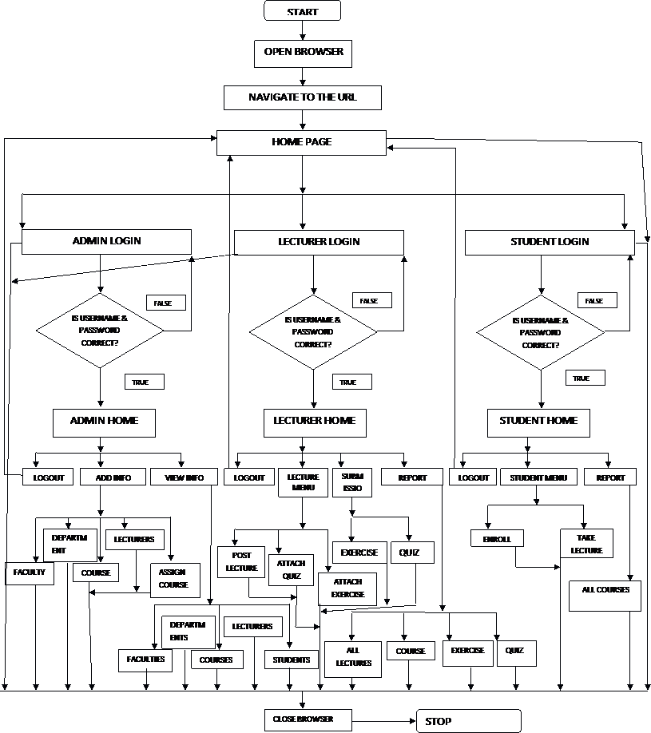

## 3.5 PROGRAM FLOWCHART

## 3.6 ENTITY RELATION DIAGRAM

REGISTER

ADMIN

LECTURER

CREATE

LECTURE

SENIOR ASST. REGISTRAR

ENROLL

COURSE

STUDENT

## 3.7 PROCESSING DESIGN

Scheduled on all pages in this project are diverse controls placed to ensure that the processing of all the required input data is taken and accurately process to give valid output. Submit buttons were used on pages to execute specified instructions attached to it. Alert Boxes and Tables are used to display information about a text field. Text fields receive data while some display results of process.

## 3.8 DATABASE DESIGN

Database is any collection of data organized for storage in a computer memory and designed for easy access by authorized users. The data may be in the form of text, numbers, or encoded graphics. Since their first, experimental appearance in the 1950s, databases have become so important in industrial societies that they can be found in almost every field of information. Government, military, and industrial databases are often highly restricted, and professional databases are usually of limited interest. A wide range of commercial, governmental, and non-profit databases are available to the general public, however, and may be used by anyone who owns or has access to the equipment that they require.

MYSQL allows a programmer to choose from a stream of connection list the connection type that the programmer is sure of using or as the need may be at times, some type of connection are advisable to be employed so as to ensure better functionality. In developing this project, MYSQL CONNECTION was used to create the connection. A module was created specifying the connection string which contains the name of the database file created with access and also specifying the server to which the database file is stored on the computer.

Database management software is described as a computer program devise to create, store and manipulate databases. Database management system come in different types examples of popular database management software are MYSQL, Micro-soft Access, Oracle, M.S Sql and lots more. This project work used MYSQL as the database management software.

# CHAPTER FOUR

## 4.0 SYSTEM TESTING AND IMPLEMENTATION

System implementation is the stage of a project during which every theory is turned to practice. During this phase, the developed software is loaded on a dedicated server.

## 4.1 BASIC SERVER REQUIREMENTS.

1. A webserver with approximately six megabytes of available disk space
2. A webserver that supports PHP, such as Apache or IIS
3. About 20 MB of storage space on the web server.
4. PHP 4.1.0 or higher
5. The following must be changed in the php.ini file.
6. The engine directive must be set to On.
7. The magic_quotes_sybase directive must be set to Off.
8. One of the following databases must be installed.
9. MySQL 4.0.18 or higher (at least 4.1.0 would be better) and PHP MySQL client API 4.0.18 or higher.
10. PostgreSQL 8.0 or higher (standard_conforming_strings must be set to off, starting from PostgreSQL 9.1 default is on)
11. The following are required of the database.
12. At least 2 MB of storage space in the database. More is highly recommended.
13. The database user must have *at least* the following privileges: SELECT, INSERT, UPDATE, DELETE, ALTER, and INDEX.

## SERVER RECOMMENDATION.

* 1. Windows, Linux or another Unix based operating system.
  2. Apache 2.0.x or above with AcceptPathInfo set to On for queryless URL support.
  3. PHP 5.2.0 or higher, with the following set in your php.ini file.

## 4.3 DATABASE SUPPORT.

1. MySQL 5.0 or higher if using MySQL and PHP MySQL client API 5.0 or higher.

2. PostgreSQL 8.3.3 or higher if using PostgreSQL.

## 4.4 BASIC CLIENT REQUIREMENTS

1. Microsoft Internet Explorer 6.0 or higher (7.0 or higher recommended).
2. Opera 7.0 or higher (9.5 or higher recommended).
3. Apple Safari 1.0 or higher (3.0 or higher recommended).
4. Mozilla Firefox 3.0 or higher (3.5 or higher recommended).

## 4.5 SYSTEM DESCRIPTION

Good description enhances usability; the following are the layout of this project pages:

**INDEX PAGE**



This is the first page of this e-learning web application. It provides access for students, lecturers, as well as visitors to the system by clicking on each menu on the page.

**STUDENT LOGIN**

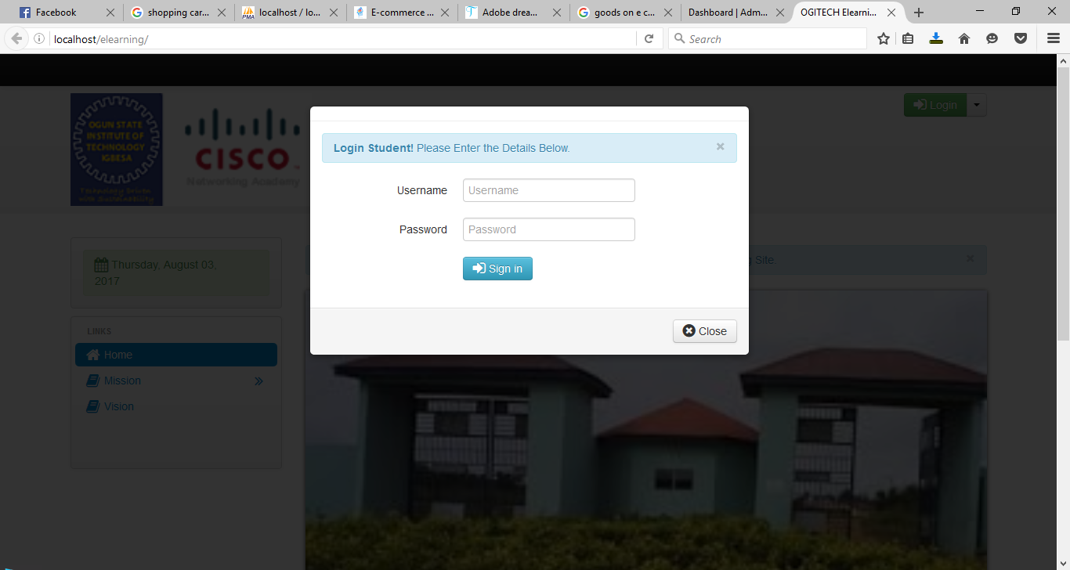

This page enables students to have access to their own account. If the password or username entered is wrong, then the system will automatically display an error page indicating that the username or password is incorrect.

**LECTURER LOGIN**

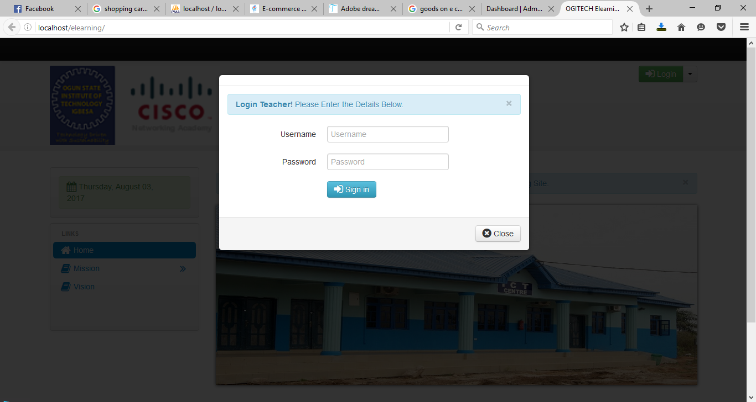

This page enables Lecturers to have access to their own account. If the password or username entered is wrong, then the system will automatically display an error page indicating that the username or password is incorrect.

**ADMIN LOGIN**

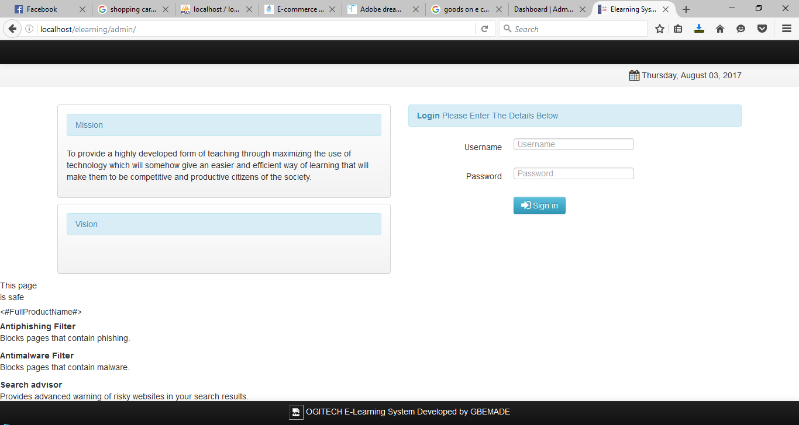

This page enables the site administrators to have access to their own account. If the password or username entered is wrong, then the system will automatically display an error page indicating that the username or password is incorrect.

**­**



This page gives the administrator super user access to the system. Here, the administrator can add department, faculty, lecturer and courses to the database of the system. The administrator can also view and edit what he/she have added. Administrators can also assign courses to lecturers and view all registered students

**ADD DEPARTMENT PAGE**

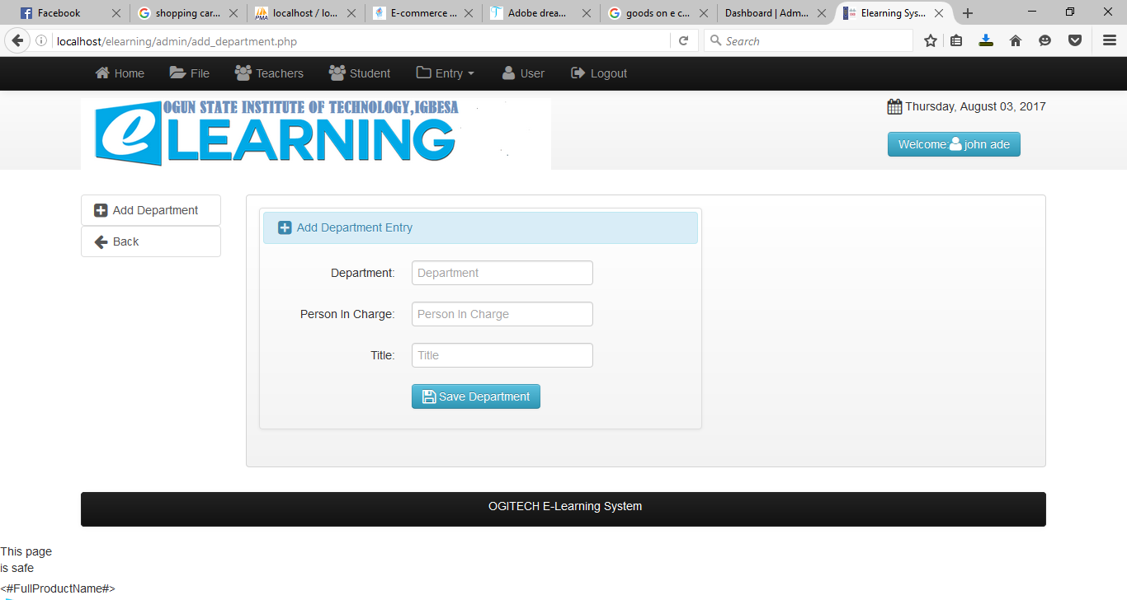

This page enables the administrator to add new department

**ADD DEPARTMENT**

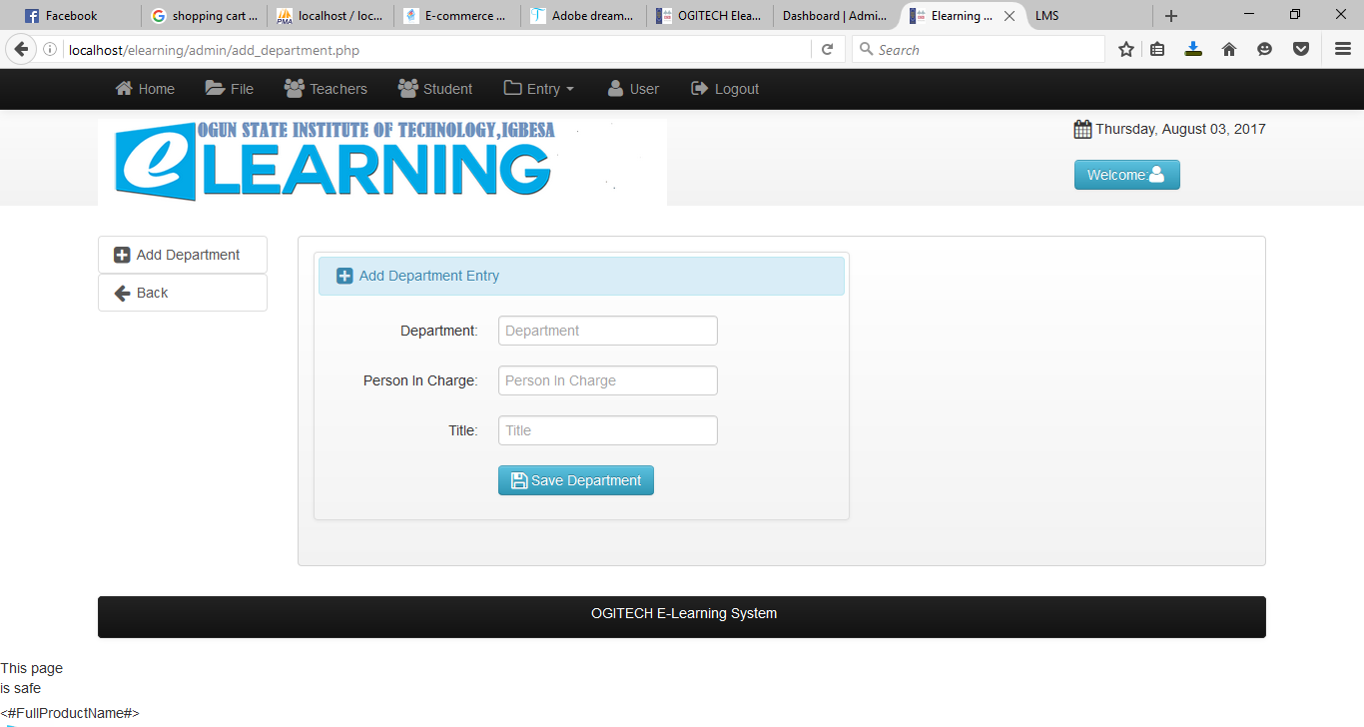

This page enables administrator to add new departments

**ADD COURSE PAGE**

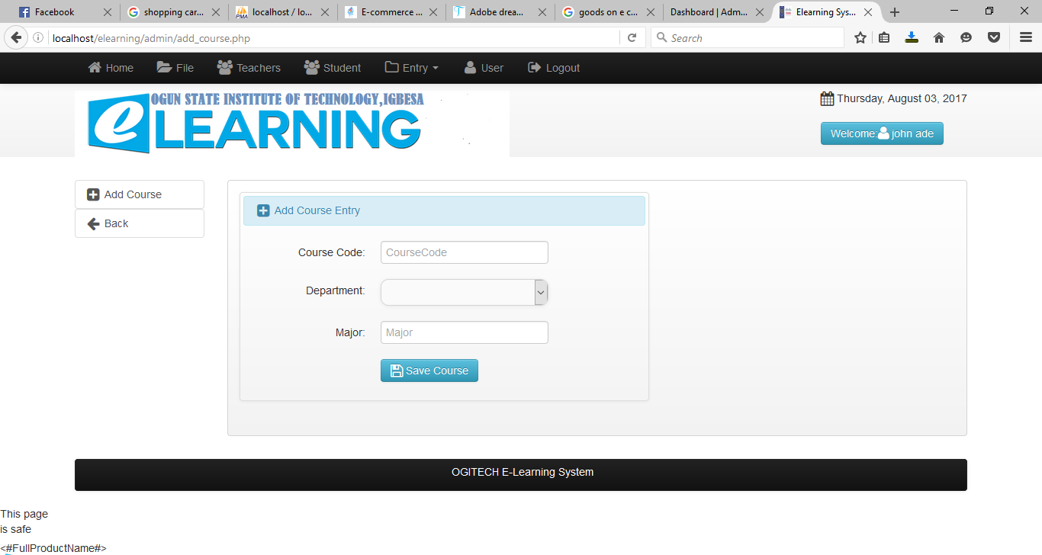

This page enables the administrator to add courses to the database of the system

**ADD LECTURER PAGE**

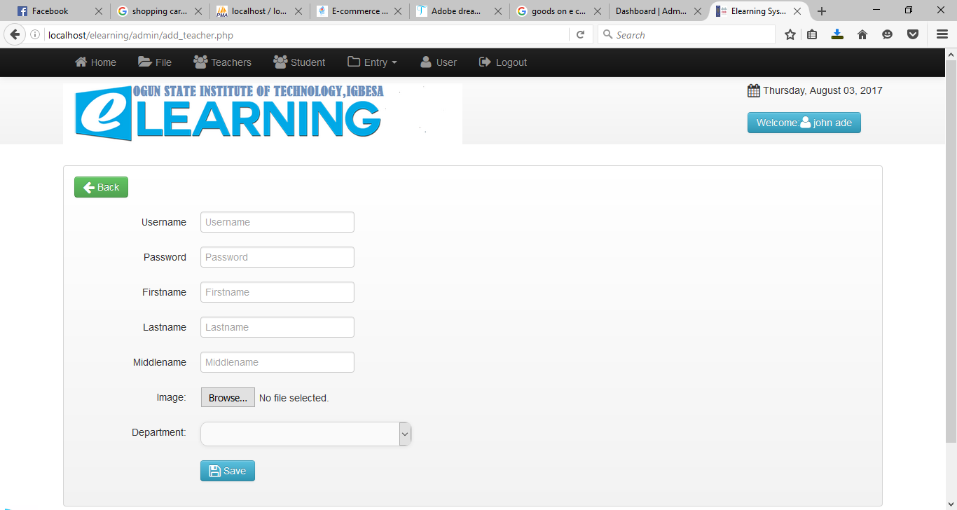

This page enables the administrator to create account for lecturers so that they can have access to the system with their username and password

**ASSIGN COURSE PAGE**

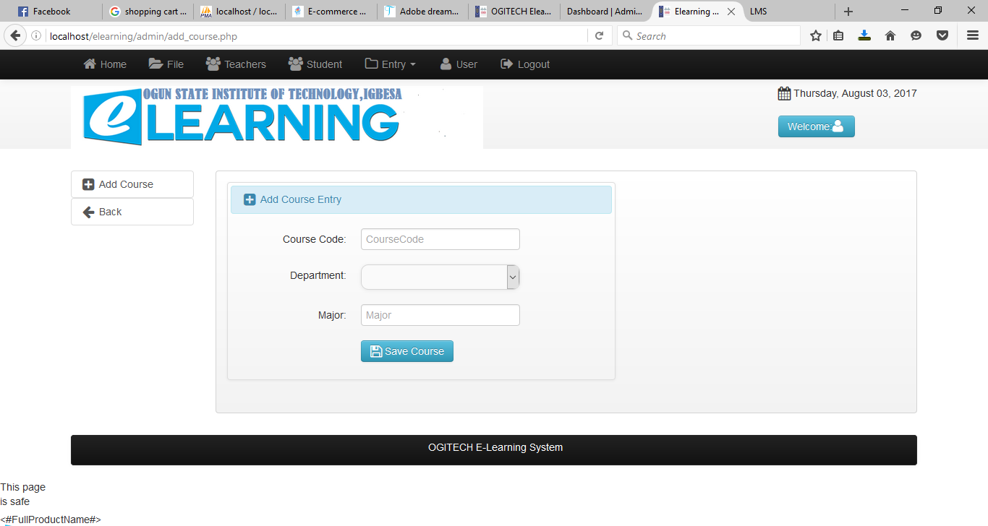

This page enables the administrator to assign courses to lecturers.

**ALL STUDENT PAGE**

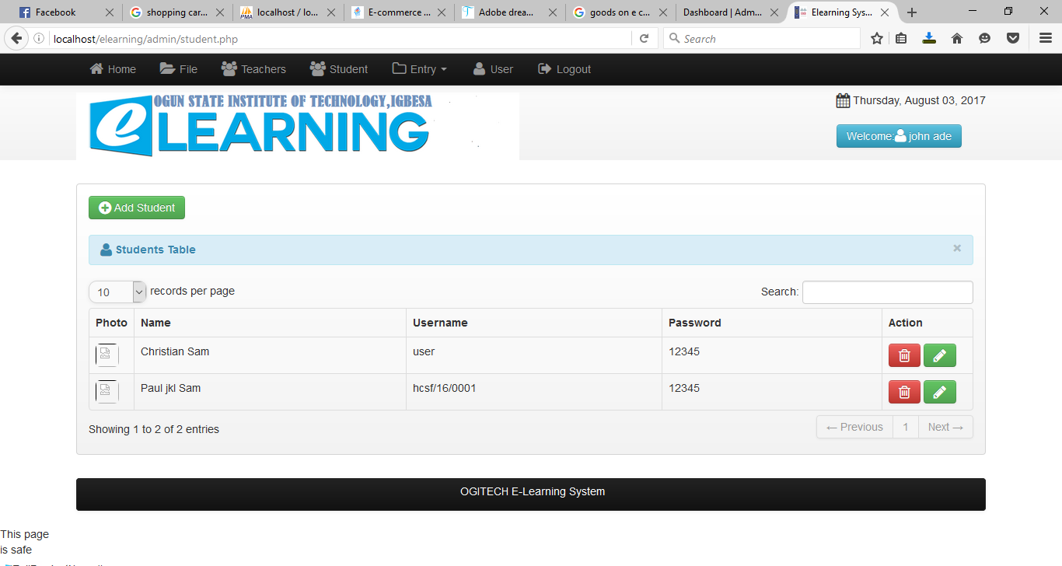

This page enables the administrator to view all registered student in the database of the system

**ALL LECTURER PAGE**

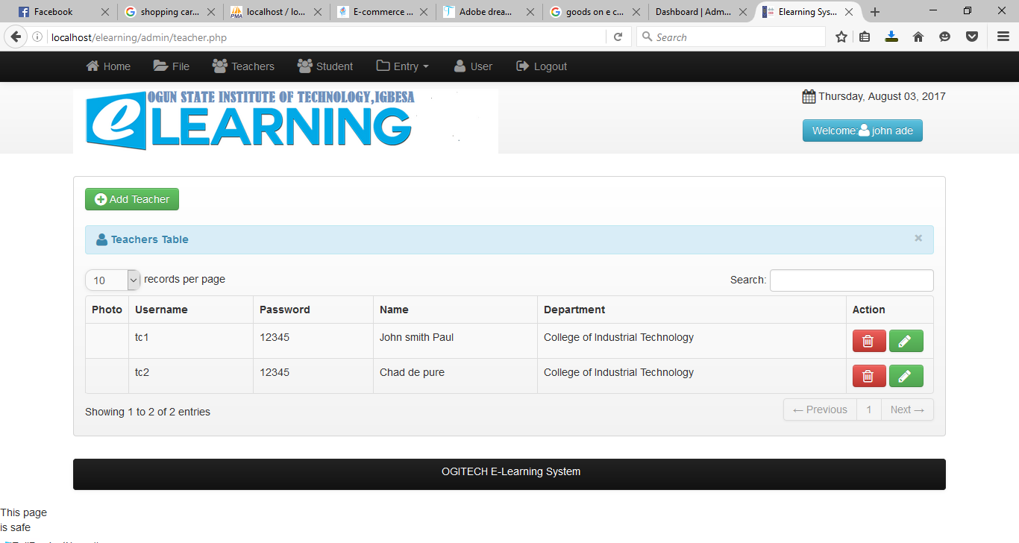

This page enables the administrator to view all registered lecturer in the database of the system

**ALL COURSE PAGE**

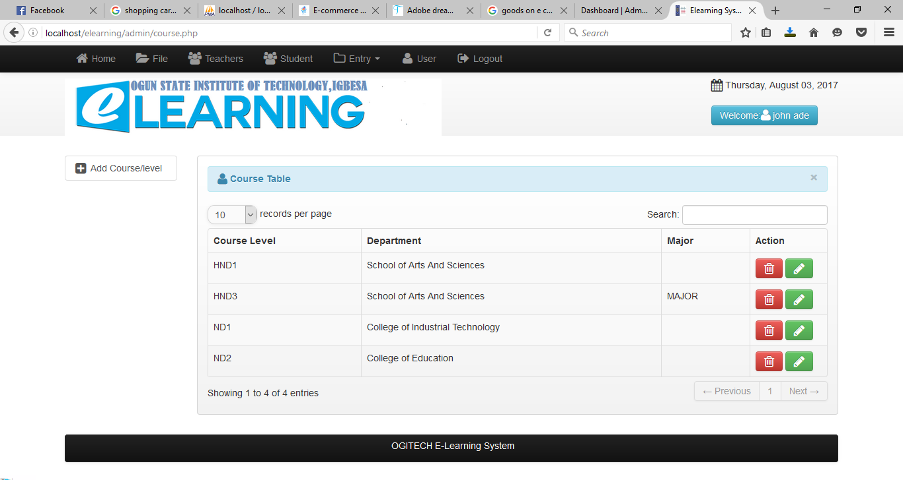

This page enables the administrator to view all registered courses in the database of the system

**ALL DEPARTMENT/FACULTY PAGE**

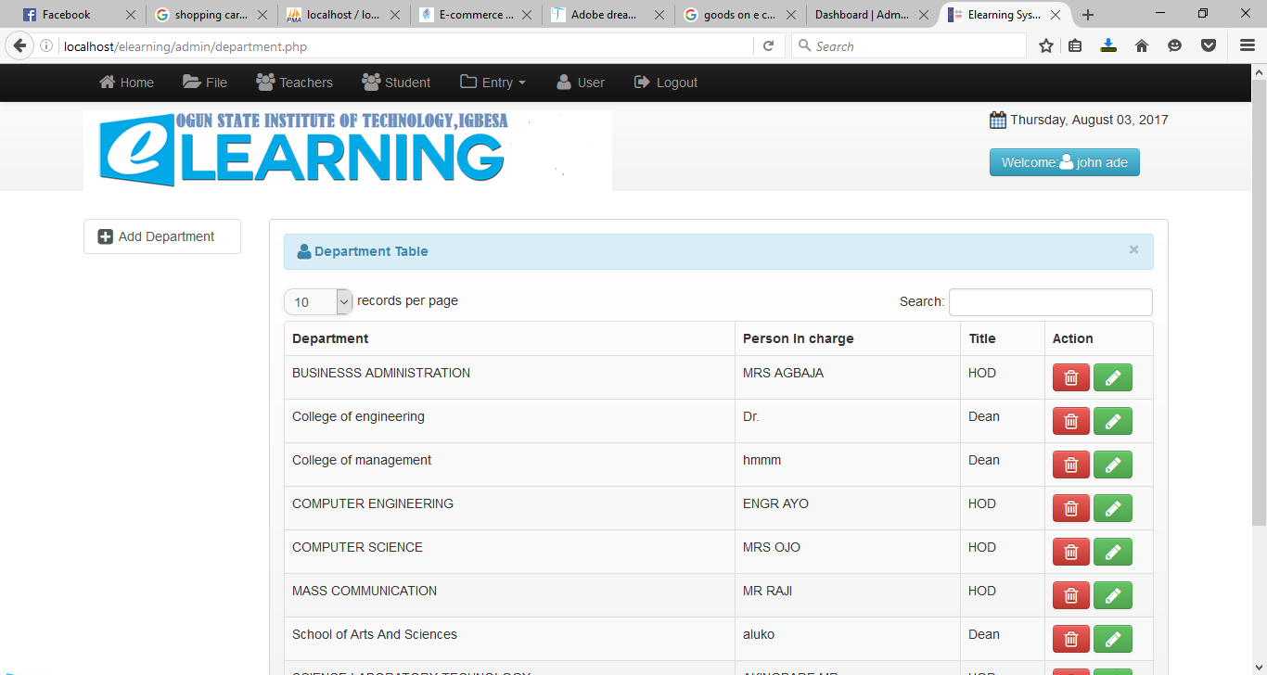

This page enables the administrator to view all registered departments in the database of the system

This page enables the administrator to view all registered faculties in the database of the system

**ALL ASSIGNED COURSES PAGE**



This page enables the administrator to view all courses that have been assigned to each lecturer in the system

**POST LECTURE PAGE**

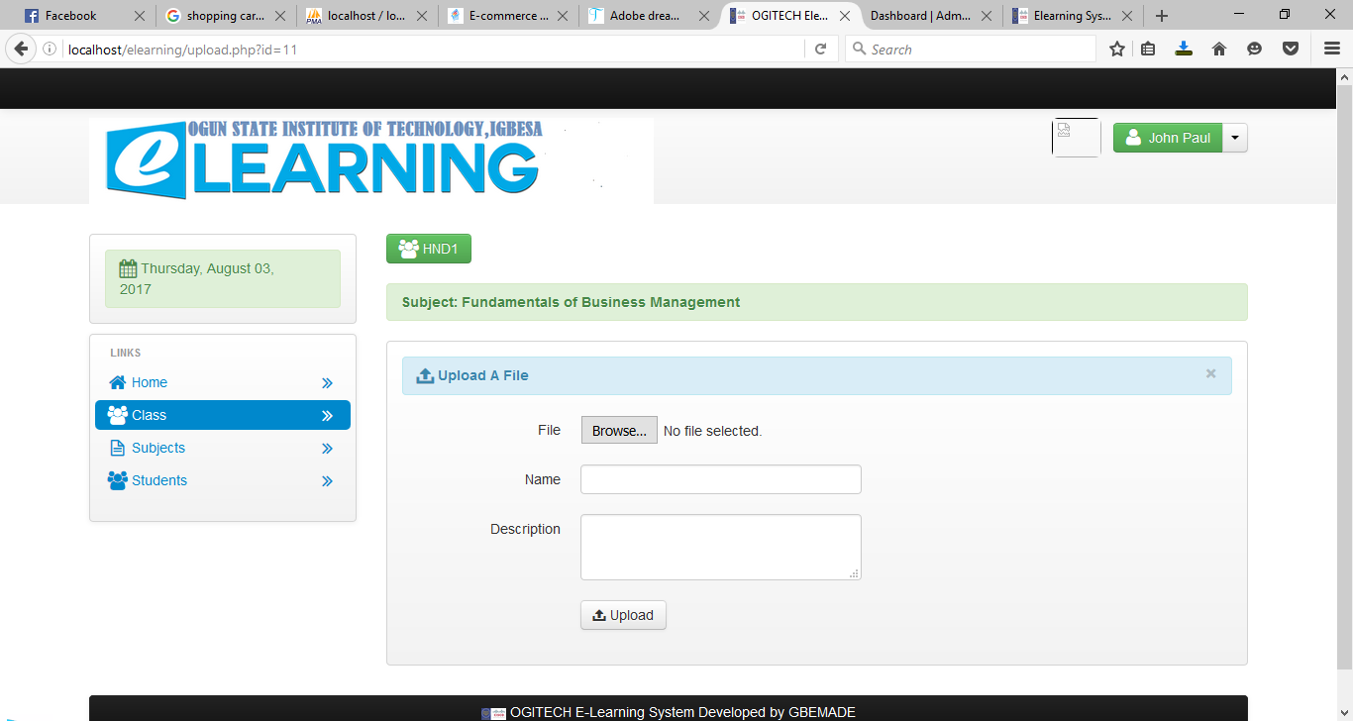

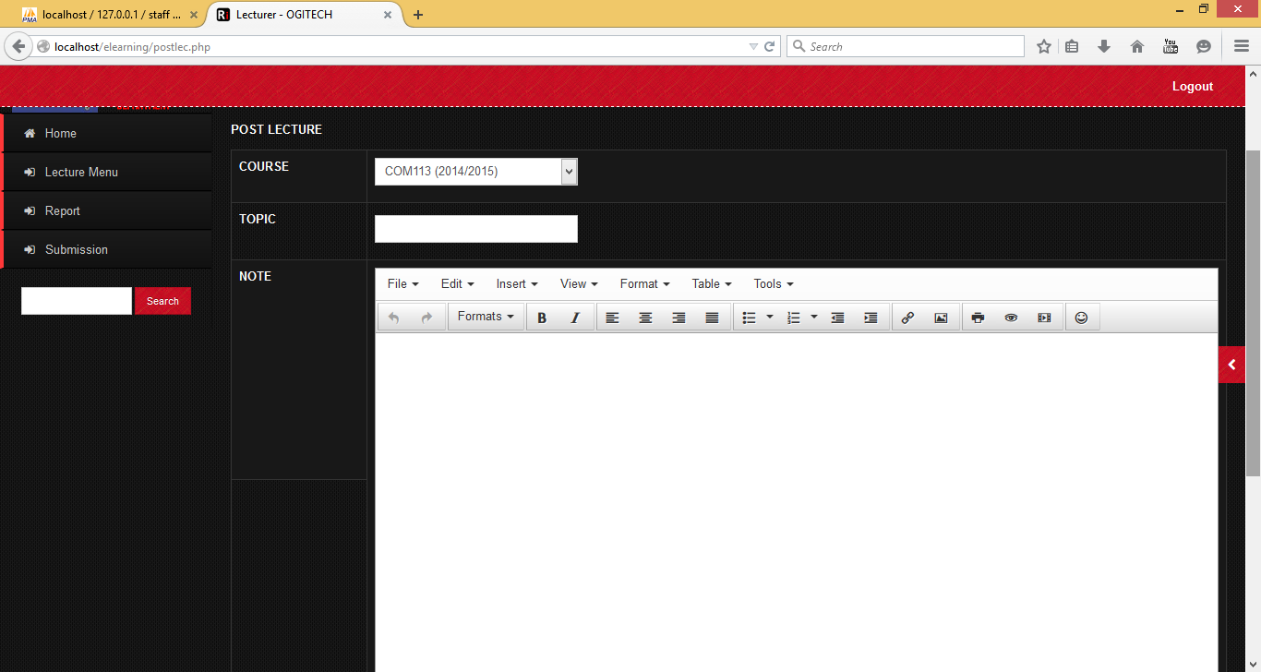

This page enables Lecturers to post lecture notes in form or text, images, video and audio.

**POST EXERCISE PAGE**

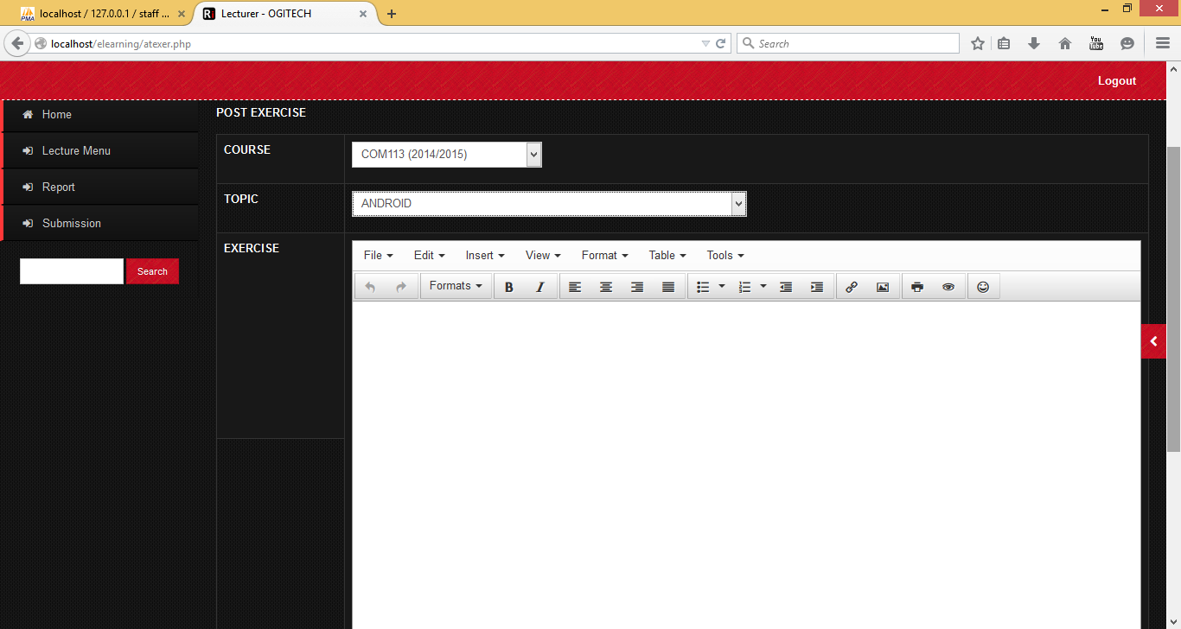

This page enables lecturers to attach exercise to lecture notes

## 4.6 SYSTEM TESTING

System testing is described as the test conducted on a total integrated system to weigh up the system’s conformity with it precise desires.The proposed system has been tested with real life data and information. Each program modules in this project has been carefully and thoroughly tested with appropriate data to ensure it works as expected.

# CHAPTER FIVE

# SUMMARY, CONCLUSION AND RECOMMENDATIONS

## 5.1 SUMMARY

This project work through critical design and dedicated supervision has been carried out and presented as a contribution to the use of information technology.

The existing system of the learning process in OGITECH was studied. It was discovered that the existing system is manually run. The major problem of the existing system which was discovered showed that, lecturers need to be present in the school to lecture students. The new system has been designed with PHP (Hypertext Pre-Processor) and MySql to take care of the inefficiencies of the old system. This system carries out online tutoring with maximum structures and accuracy. It is depressing that there is slow adaptation to new technology in various organizations. But I hope that after the introduction of this software, there will be a change.

## 5.2 CONCLUSION

The conclusion of this project work is based on the advantage of computer-based system over a manual system. This project work in success has produced a database driven software which can be used to lecture students. This is software helps lecturers to lecture student virtually by uploading lectures note in form of text, document, audio or video. It is also provide an avenue where student can be able to forward question pertaining to a course to the lecturer in charge of the course.

## 5.3 RECOMMENDATIONS

Computer has become an indispensable tool to all fields of human Endeavour. For the lecturers to be able to perform the functions which include lecturing and grading? There is need for a computerized system.

When most lectures are received online by the student, it will go a long way to help the lecturers. I therefore, recommend this software to the school, if not now, should consider it in future.